Iowa City Greenhouse Gas Inventory and Climate Action and Adaptation Plan Metrics Progress Report

2018 through 2022

# Overview

Iowa City has the distinction of maintaining the longest running set of annual Greenhouse Gas (GHG) inventories of any community in Iowa, extending back to 2005. The data collected for these annual inventories was instrumental in the development of the Climate Action and Adaptation Plan (CAAP) adopted in 2018, and the Accelerating Iowa City's Climate Actions Plan in 2020. Between the two plans, more than 65 actions to help lower GHG emissions were identified for Iowa City to pursue. GHG inventories help prioritize actions by providing insights into emissions sources. The emphasis on energy efficiency in Iowa City programs, for example, arose from the large share of emissions contributed by energy usage in buildings. However, as the practice of climate planning evolves nationally, a consensus is emerging that local-level GHG inventories make a better compass than speedometer. This is because the cumulative effects of actions, such as increased energy efficiency in individual households, may take a decade or more to be noticeable in the graphs[1], obscuring the progress being made. In contrast, large regional initiatives that impact all households at once, such as increased renewable energy on the grid, appear more readily. To better track efforts on local programs as well as help inform future decision making, this report offers several complementary metrics in addition to the most recent GHG inventory. As these measures show, Iowa City has achieved much, in a short amount of time, that deserves celebration, even as we work to build future successes.

## GHG Emissions by Year

Iowa City Greenhouse Gas Emission Targets: 45 percent reduction by 2030, net zero emissions by 2050.

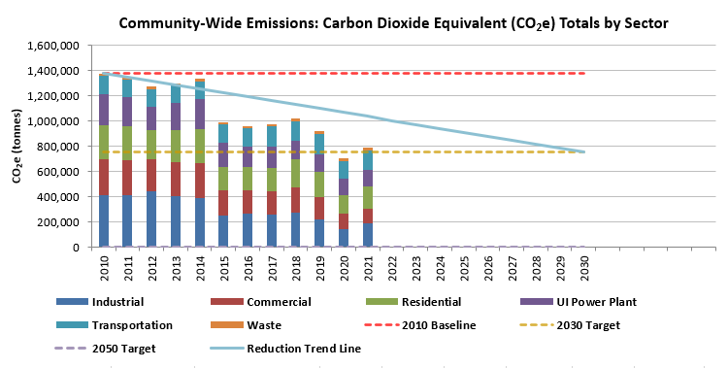

The Big Picture: A 2 percent reduction in GHG emissions year over year is required to achieve Iowa City's net zero goal by 2050. The overall trend since 2010 is downward. As Iowa City gets closer to our net zero goal, the work will become more challenging. In 2020 we met our 2030 goal early. In 2021, in part as activities curtailed during the pandemic resumed, we crept back upward. Some fluctuation is to be expected from year to year, making 5-year increment comparisons more useful to see overall trends. The recent fluctuation is particularly useful, though, as it provides clues as to areas where near-term reductions might be made, such as in the transportation and industrial sectors.

## GHG Emissions by Sector: 2018 to 2021

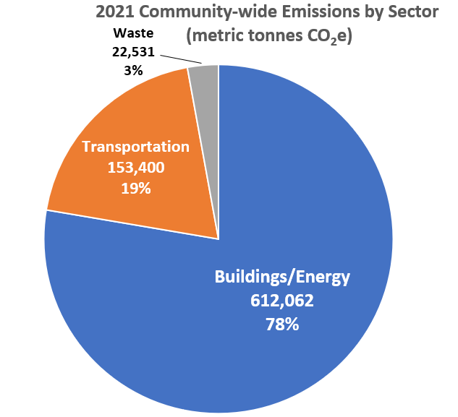

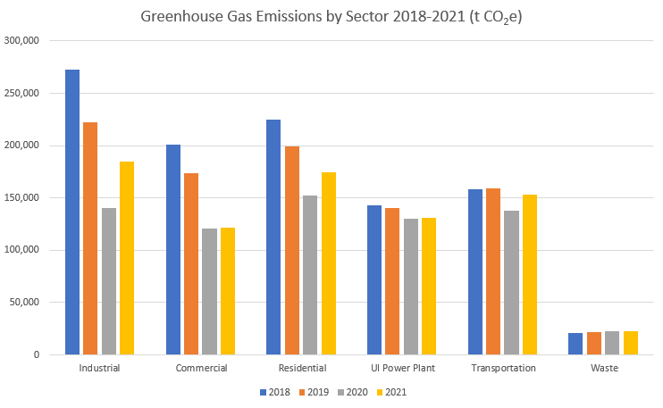

Overall, impressive emissions reductions have been made in the industrial, commercial, and residential sectors, largely resulting from the increased share of wind energy on the grid. Despite an additional 5 percent growth in renewable energy resources in 2021[2], emissions went back up, which suggests clean energy advancement alone is not enough. We also need to be working to reduce energy usage overall and making smart use of the renewable energy we have. There is important work to be done in the form of beneficial electrification, particularly in the transportation and residential sectors. The more we can switch from burning fossil fuels in our vehicles and homes to using electricity, and the cleaner that electricity gets, the lower our emissions will be.

# Buildings and Energy

There are important differences in energy use by building type in Iowa City. In residential and commercial buildings, more than half of emissions result from fossil gas usage, while in industrial buildings more than three quarters are from electricity usage. Decarbonization strategies for households therefore focus both on energy efficiency and advancing electrification, as with the annual Energy Blitz and income-qualified grant programs. Meanwhile, in industrial operations our TIF-funded rebates emphasize energy efficiency and renewable energy installations.

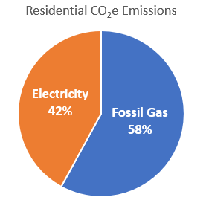

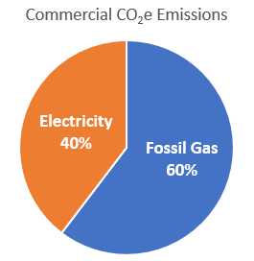

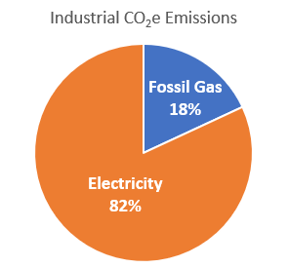

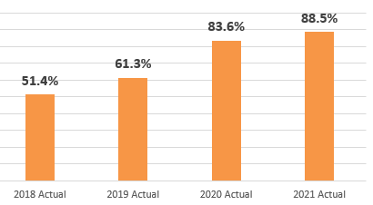

Energy efficiency also has important equity implications. As we transition to renewable energy generation, reducing energy usage overall reduces the capital investment needed to achieve 100% clean energy goals, keeping utility rates low for all residents in Iowa City. Iowa City's energy efficiency initiatives thus work in parallel with MidAmerican Energy's efforts to increase clean energy.

## Energy Use at Home for Iowa City residents

The average individual in the US has a carbon footprint of 14.9 tonnes[3], and roughly 20 percent of those emissions result from household heating, cooling, lighting, and powering electronics.[4] In Iowa City, annual housing-related emissions equal 2.3 tonnes CO2e (carbon dioxide equivalent) per capita, compared to the US average of 2.9 tonnes per capita. Much work remains to be done, though. To achieve the carbon reduction goals established by the IPCC, we should aim for a combined 2 tonnes per capita total from housing, transportation, food, goods, and services.[5]

In 2018, 2.9 housing-related tonnes CO2E per capita were recorded in Iowa City.

In 2021, 2.3 housing-related tonnes CO2E per capita were recorded in Iowa City.

New grant programs to fund insulation, electrical panel upgrades, and heat pump heating and cooling systems in income-qualified households were rolled out in 2022. Following a targeted "What R You?" insulation marketing campaign in November featuring Goldie, the climate action mascot, program applications increased 650%.

Iowa City residential energy efficiency and electrification 2022 grant total: $80,890

## Insulation Grant Programs

“I would definitely recommend this to anybody. I would have your insulation inspected and definitely apply for funding to help because it’s made a huge difference.” - Cathy Coleman, Deerfield Commons resident

A 2021 Climate Action Grant for the Deerfield Commons Homeowners Association raised the R-value of the attic insulation in 22 units from zero to 30, increasing comfort within the homes, eliminating ongoing structural damage from rooftop ice dams, and lowering energy costs for residents.

## Energy Audits and Energy Saving Kits Received by Iowa City Households

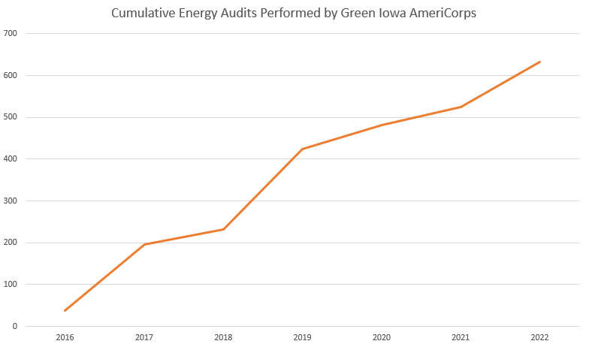

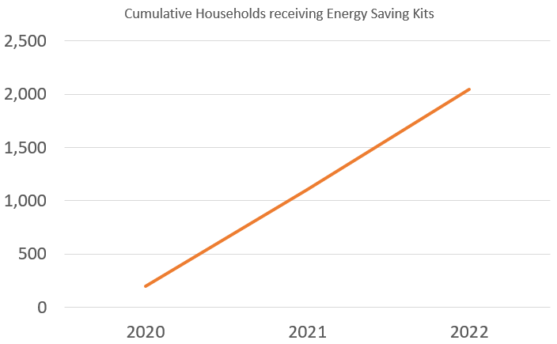

Two important efforts are underway to engage Iowa City residents with energy efficiency. The household energy audits performed by our Green Iowa AmeriCorps team identify air leaks and provide key weatherization services. In the annual Neighborhood Energy Blitzes, community volunteers go door to door to deliver energy saving kits. Combined, these programs have reached more than 2,500 households since 2016.

## Climate Action Grants

Climate Action Grants empower community groups and businesses to take an active role in helping the city achieve its climate action goals. Since 2018, more than $88,000 has been awarded through this grant program, which provides funding in amounts up to $10,000 per project. As the program has matured, increased emphasis on aligning the funding with the emissions reduction goals of the Climate Action and Adaptation Plan have resulted in a greater share of the grants supporting projects related to energy and transportation.

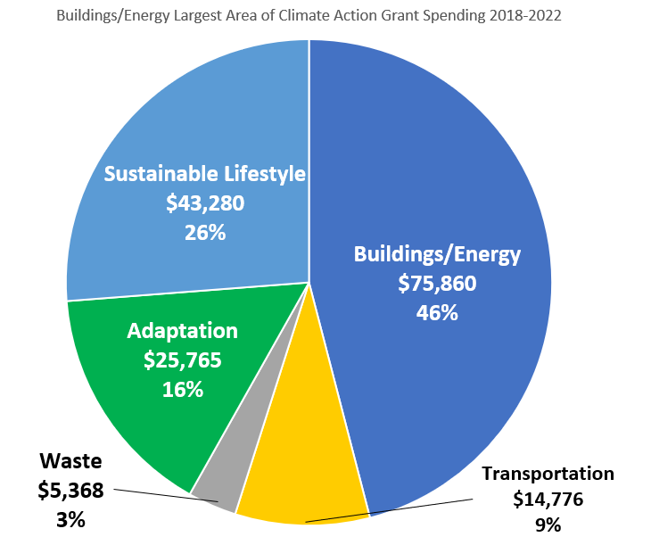

Community Climate Action Grant Projects 2021-2022

* A&W Sustainable Planning: Resilience hub focus group and report
* Bike Library: New, efficient windows, doors, and LED lighting
* Deerfield Common: Insulation for 26 households
* Beadology: High efficiency furnace and LED lighting
* Bicycle Happines: Bike clinics
* Highlander Hotel: Electric Vehicle (EV) charging station
* Field to Family: COVID-adapted Farmers Market
* DVIP & Shelter House: Rooftop solar panels
* Iowa Valley RC&D: Local food production
* Johnson Clean Energy District: LED light bulbs and low flow shower heads
* Multicultural Development Center: Extreme weather preparedness workshop for youth

Commercial & Industrial Matching Grant Projects 2021-2022

* Adamantine Spine Moving: PV Solar Array
* Alpla: Chiller & cooler replacements, LED lighting
* Big Grove Brewery: Carbon Capture/Recycling System
* Earl May: PV Solar Array
* First Ave Mini Mall: PV Solar Array & LED lighting
* Iowa City Storage LLC: PV Solar Array & LED lighting
* Lasansky Corporation: Window replacement & high-efficiency furnaces
* Old Capitol Tofu: High-efficiency HVAC replacement
* Proctor & Gamble / Oral B: High-efficiency air compressor
* Reunion Brewery: PV Solar Array
* UNFI: LED lighting

"Right now, the hundred solar panels on our roof are meeting about 80% of our energy needs for the year, which is great. I feel grateful to living in a community where it’s a priority because action was needed yesterday. The local action for small businesses like us who don’t have unlimited resources but want to do the right thing is just huge." -Eric Jones, TIF-funded Energy Efficiency Grant recipient and co-owner Adamantine Spine Moving

# Transportation

Iowa City in 2021:

* 4,595 vehicle miles traveled per capita
* 2.02 tonnes CO2e per capita in GHG Emissions

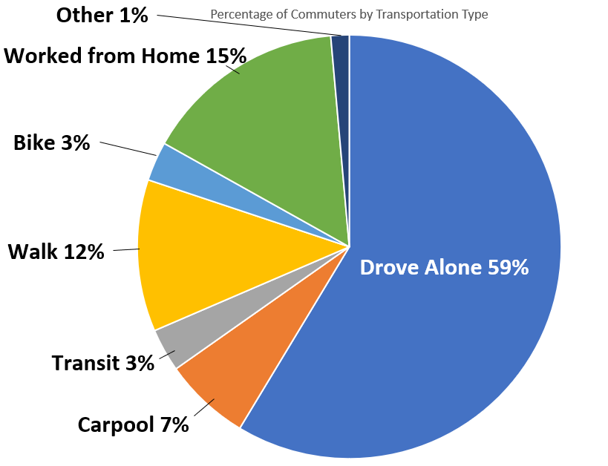

Transportation emissions account for the second largest segment of Iowa City’s GHG emissions, and the largest nationally.[6] A major factor in the overall drop in emissions observed in 2020 and the rise in 2021 was a parallel drop and rise in transportation emissions. Residents are likely to continue driving at pre-pandemic levels in the near term, suggesting electrification strategies for transportation will be key to recapturing the emissions reductions recorded in 2020 and maintaining the trend toward net zero emissions by 2050. Iowa City residents walk and bike to work at rates roughly five to seven times higher than the national average,[7] but active transportation still accounts for far fewer trips (15 percent) than driving in single occupancy vehicles (59 percent). Travel behavior is complex and impacted by a number of factors, including proximity to childcare and seasonal weather patterns. For this reason, an "all of the above" strategy that encourages walking, biking, transit ridership, and electrification of vehicles remains the best pathway to achieving Iowa City's emissions reductions goals.

## Leading the Charge

Encouraging adoption of electric vehicles is a prime example of beneficial electrification, as it harnesses clean energy resources to help displace fossil fuel usage and drive down emissions. An important finding of the Eastern Iowa Electric Vehicle Readiness Plan (EVRP), completed in 2020, was that 450 public charge ports per million population were needed to serve as a tipping point to spur electric vehicle (EV) adoption locally. In 2022, Iowa City exceeded this goal with the equivalent of 660 charge points, adjusted for population size. Efforts are now underway to shift the focus toward increasing charging infrastructure at multifamily housing. More than half of Iowa City residents are renters, and more than 80% of electric vehicle charging happens at home. The ability to charge an EV at an apartment or condo is more than a matter of convenience. With the anticipated rollout of Iowa's public EV charging tax in 2023, helping renters access charging where they live decreases the likelihood that they will disproportionately bear the brunt of this tax. By adding both electric buses and electric light duty vehicles to its fleet, Iowa City has demonstrated leadership in advancing EVs. These vehicles serve as important ambassadors to the community at large, demonstrating the reliability, value, and benefits of these vehicles. The electric buses in particular meet several climate action objectives, increasing the attractiveness of transit ridership while decreasing associated emissions and helping align city operations with our climate goals.

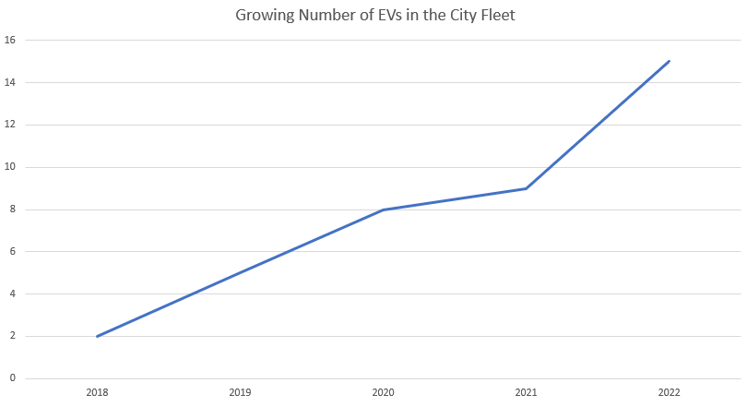

## Iowa City Transit & Climate Action

“The electric buses switch routes so everyone has a chance to experience them, and there’s a lot of enthusiasm when the electric bus comes to your route. You see people taking pictures of them when you come to a stop. It really puts a smile on people’s faces. And the regular riders, when they get on, they ask you 'How do you like driving it? How long does it take to charge?' People are excited to see Iowa City taking that step and making that change.” - Ken Gatlin, Iowa City Mass Transit Operator

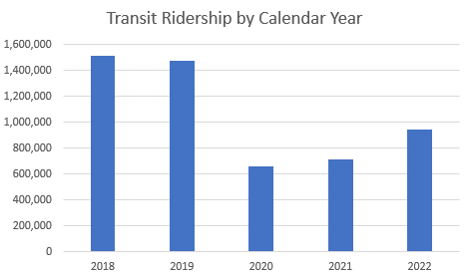

## EV Charging Stations

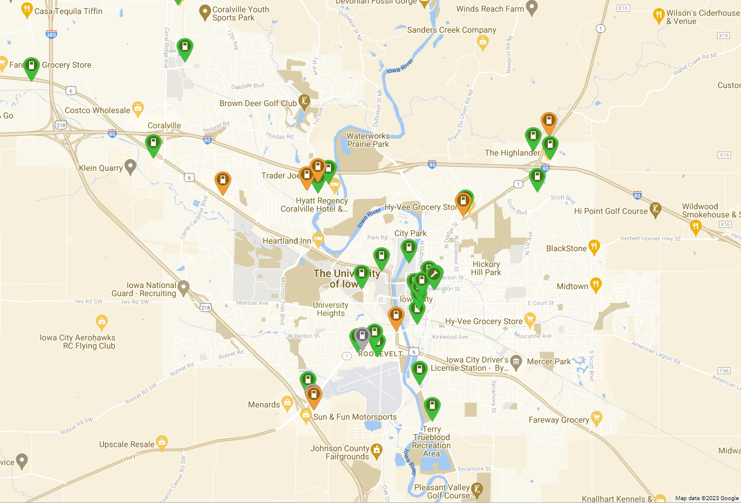

Investments in public charging stations in Iowa City at both municipal and private sector facilities have resulted in a robust network of charging stations that include both level 2 charging (shown in green) and level 3/DC fast charging (shown in orange). (Map courtesy of PlugShare)

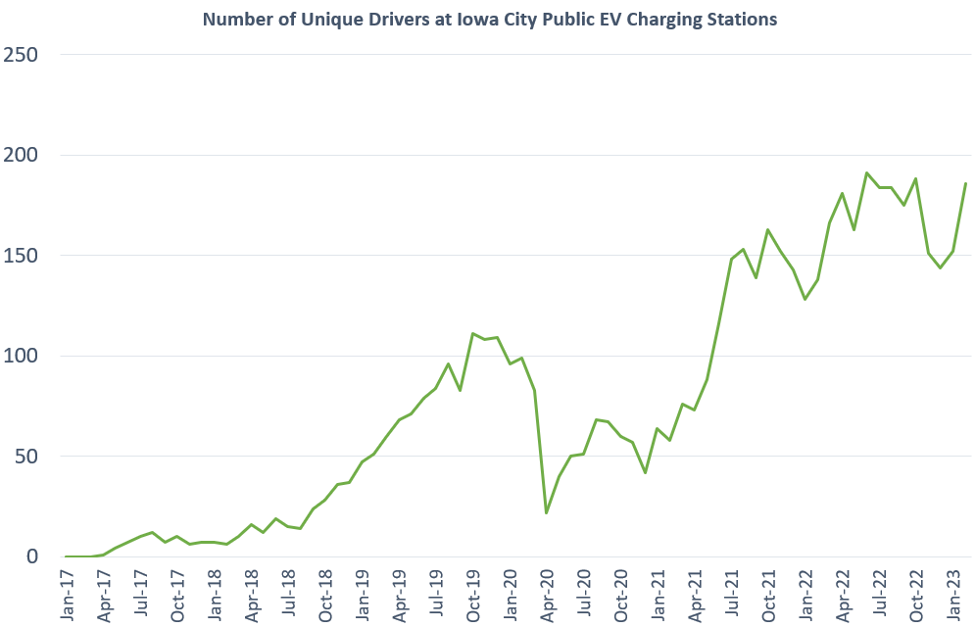

The number of unique drivers plugging in to Iowa City's EV chargers in the downtown ramps reflects not only the usage of that service but also the increased adoption of EVs locally (and by visitors). By 2022, the amount of GHG emissions saved by EV charging at public ramps reached the equivalent of planting 2,000 trees and letting them grow for 10 years: 121.33 tonnes CO2e.

## Equity & EV Charging

“Probably the most significant climate action I took this year was getting an electric car. We're lucky in Iowa City because close to 85% of our electricity comes from renewable sources, mostly wind. Because I live in an apartment, I usually plug my car into a nearby public charging station and leave it there for a couple hours while I go about my life. If you live in a house, you can install a charger there and just leave your car plugged in overnight. I really love zipping around in my wind-powered car!” - Patricia Valderrama, Climate Ambassador

In 2022, the City launched a rebate program for electric vehicle charging at apartment buildings and condo complexes. Building owners and managers wishing to provide electric vehicle charging to their residents may apply to the City of Iowa City for a 50/50 match of installation costs (labor and materials).

# Waste in Iowa City: 2021

Although emissions related to waste form the smallest segment of GHG emissions in Iowa City overall, achieving net zero emissions ultimately will require us to address these emissions as well. Important efforts continue to be made to divert organic material from the waste stream, reducing future methane emissions by the landfill. Even with impressive increases in the amount of material recycled and composted in the last three years, it did not result in overall waste reduction. Landfill tonnage grew by 7 percent in the same timeframe, driven largely by increased use of disposable items and delivery services during the pandemic. These numbers underscore the importance of the comprehensive waste reduction strategy in the Climate Action Plan that pairs curbing consumption with other waste diversion efforts.

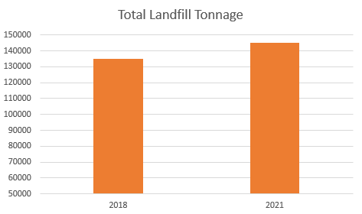

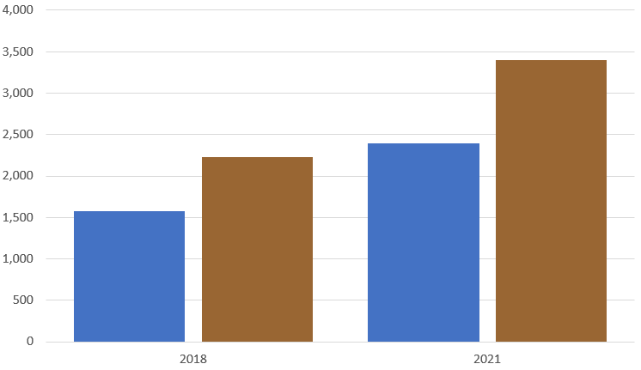

Landfill tonnage increased 7 percent

* Recycling tonnage increased 52 percent
* Organics tonnage increased 53 percent

## Waste Diversion Goals

Decrease Food Waste: Organic material accounts for the majority of GHG emissions associated with waste material. The most recent waste characterization study by the Iowa Department of Resources (IDNR) estimated 24 percent of the material landfilled in Iowa City is organic matter, almost all of which is food waste. Diverting such waste remains a top climate action goal.

Divert Construction & Demolition Waste: Construction and demolition waste tends to rise and fall in tandem with prevailing economic trends. Because of the complex mix of materials involved, it tends to be more resistant to recycling initiatives. Even so, staff continue to investigate opportunities to divert such waste, which accounts for 18 percent of total landfilled material.

Reduce Single-Use Plastics: Plastic accounts for 14 percent of material landfilled in Iowa City. Not all this material is recyclable, and of the material that is, recycling potential is limited. For this reason, reusing durable plastics and reducing single use plastics are key strategies for addressing this part of the waste stream locally, while staff work with regional and national partners to encourage manufacturers to reduce single use plastic broadly.

Recycle More Paper, Glass and Metal: Although these materials do not contribute significantly to GHG emissions once in the landfill, their high recycling potential makes diverting them good resource management policy. Efforts to reduce the amount of this material sent to the landfill will continue.

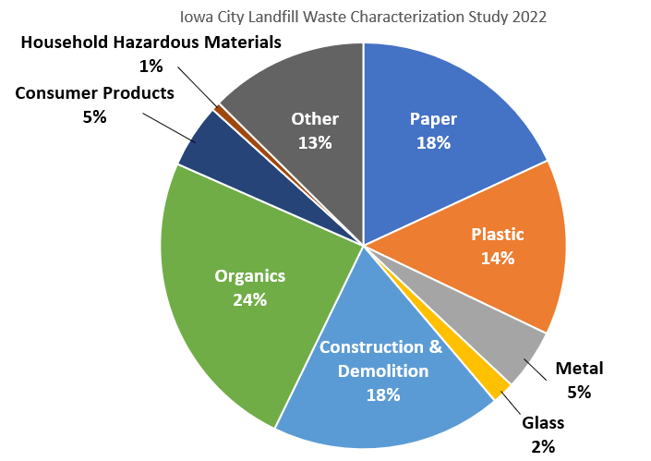

## Garden Bed Project Reduces Waste

"The Sustainable Raised Garden Beds and Garden Tables project utilizes urban lumber to create raised garden tables for the Iowa City community. Repurposing urban lumber and hardware from Restore and windows from The Salvage Barn keeps these materials out of our landfill. The process of growing one's own food also influences people to think about where their food comes from and discourages food waste." -Blaise Boles, Climate Ambassador, faculty advisor to Kirkwood Community College Sustainability Club

A 2022 Climate Action Grant awarded to the Kirkwood Community College Sustainability Club supports goals of sustainable lifestyles, adaptation, and waste reduction.

# Adaptation

Even as we work to lower emissions in hopes of preventing the worst effects of climate change, we will continue to be subject to some of the impacts already being observed in our area. This includes more days with temperatures over 90 degrees, more frequent and heavier precipitation in the spring and summer, and increased frequency of freeze-thaw cycles stressing our infrastructure. While we continue our mitigation efforts, we must also be investing in climate preparedness measures to address this coming challenges. Because climate change amplifies existing vulnerabilities, preparedness must include an awareness of current social and health challenges within the community and work in tandem with efforts to address existing inequities. This includes vulnerabilities as apparent as susceptibility to heat stress and as subtle as social isolation. Adaptation measures should not only seek to build more robust infrastructure but also a more resilient social fabric for life within Iowa City.

Vulnerabilities

* Six percent Iowa City renters survey respondents have no usable air-conditioning
* Twenty-one percent Iowa City renters survey respondents say the cost of electricity is a barrier to their use of air conditioning[8]
* 976 Iowa City households are in a floodplain
* 498 Iowa City households participate in National Flood Insurance Program

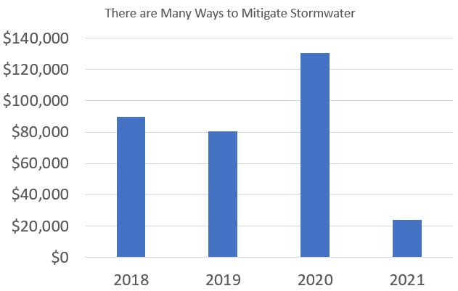

Projects include Rain Gardens, Soil Quality Restoration, Permeable Pavement, Rain Barrels, & Creek Projects

## Iowa City Tree Canopy and Urban Heat Islands

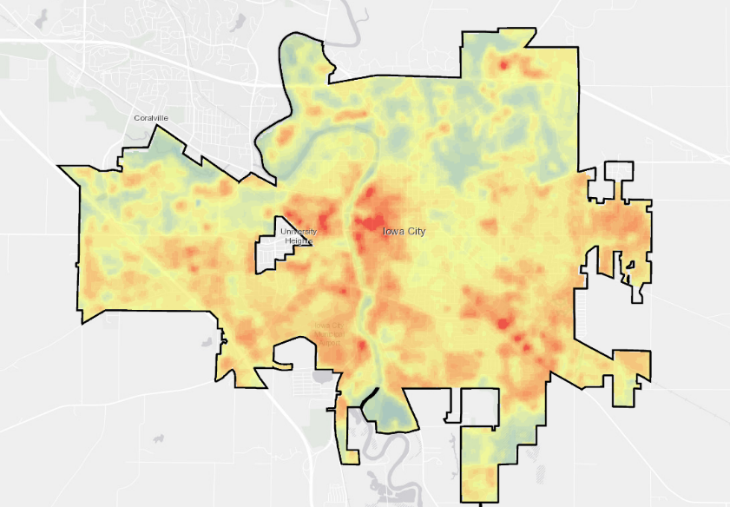

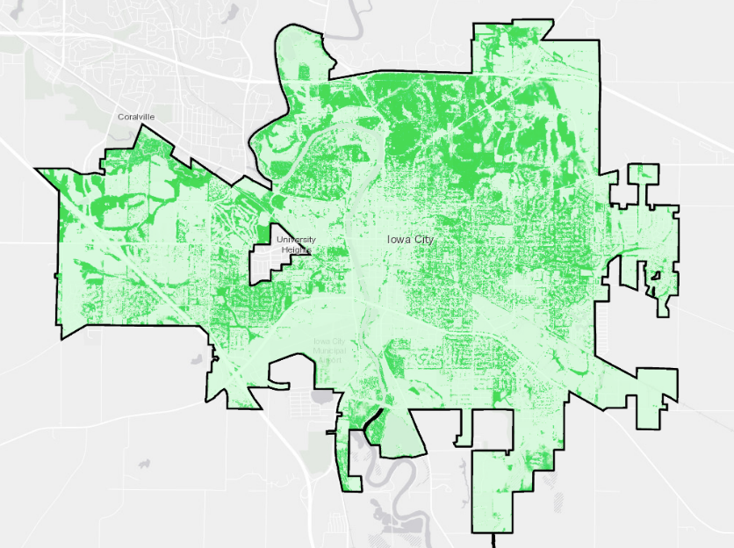

A side by side comparison of Iowa City's tree canopy (top) and urban heat islands (bottom) from the 2020 Iowa City Carbon Management Study shows the temperature can be as much as 11-13 degrees higher than the median in areas with the fewest trees.[9] A recent addition to the commercial energy efficiency matching grant program offers cost sharing to paint rooftops white for downtown businesses where building heights pose challenges for shade tree coverage.

Trees build resilience:

* 699 Root for Trees vouchers redeemed to date
* 2,250 Trees planted by the City 2018-2021
* $428,000 Estimated value of the energy efficiency benefits resulting from Iowa City's tree canopy, which also sequesters more than 6000 tonnes of CO2 annually

## Climate Resilience Corps

"When I joined Iowa City’s Climate Resilience Team through my school’s environmental club, I had the opportunity to speak with my neighbors about their experience with extreme climate-related disasters, like the derecho, and educate them about how they can take climate action and plan for disasters in the future. Research shows that Americans are much more likely to take climate action when it’s suggested by a friend or family member than by a political or community leader. Because of this, I believe that one of the best ways to take climate action is to just discuss these issues with your friends, family, and neighbors." - Althea Downing-Sherer, member of Iowa City Climate Resilience Corps

In 2022, the City launched a Teen Climate Resilience Corps program to build up neighborhoods' capacity to adapt to the changing climate.

# Sustainable Lifestyle

One of Iowa City's most significant strengths is the sincere desire residents have to take meaningful steps to address climate change. For many, this means not only continuing the practices they have already embraced but also looking for next steps. Nothing could be more critical, as our GHG inventories show only 5 percent of total emissions result from municipal operations. For the remaining 95 percent of emissions, we need the collaboration, creativity, and commitment of our residents, businesses, organizations, and nonprofits to get to net zero.

Climate change is a complex problem that no single solution is going to fully address. Ongoing engagement efforts seek to raise awareness of Iowa City's efforts, connect community members with resources to further their own climate actions, and aid residents in making informed decisions on topics as diverse as shopping for local foods, supporting local entrepreneurs in sustainability, and navigating tax credits for energy efficiency home improvements. Marketing platforms utilized include utility inserts, bus ads, radio and newspaper ads, social media channels, webinars, live events, and a monthly Climate Action newsletter.

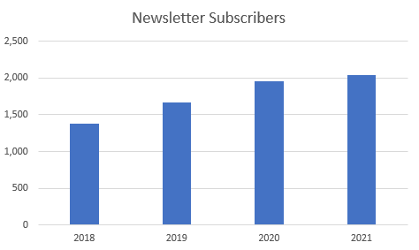

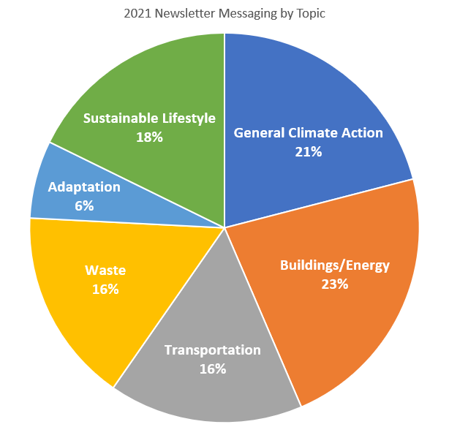

## Food Insecurity, Community Gardens and Local Foods

* 1.63 acres of community garden plots in Iowa City
* 15-20 individuals on the waitlist each year for a community garden plot
* 59,000 dollars spent on local food initiatives since 2016 through Farm to Street and Climate Action Grants
* 15 percent of Iowa City's population is food insecure

## Goldie, Climate Action Mascot

A major goal identified in the Climate Action and Adaptation Plan was to create a cohesive marketing plan that could help promote climate action tips and information to the public. Enter Goldie, Iowa City's new climate action mascot, which debuted at the 2022 Climate Fest. Much like Smokey the Bear or Woodsy Owl, Goldie is designed to be friendly, helpful, and informative while at the same time signaling an action's importance in addressing climate change.

Initial Goldie campaigns have touched on energy efficiency and climate resilience, with campaigns connected to local water resources, active transportation, and waste diversion among those planned for 2023.

## Climate Fest

The stories we tell about climate action matter. News cycles dominated by extreme weather events, intractable industries, and ongoing environmental harms can all make solutions feel out of reach, especially on the individual level.

To effect change, stories of progress being made and climate solutions gaining ground are just as important. They point to the ways individual actions add up when taken collectively, reminding us of the tools we have to build a better future and the resources we have in each other.

Climate Fest is an annual celebration of the climate work being done in Iowa City, meant to empower and inspire. Held each September, first virtually in 2020 and then in person in 2021 and 2022, it has grown to include multiple events over the course of several days, drawing hundreds of participants and tens of thousands of social media views.

Climate Fest Highlights:

* Mural Painting: Unique event in 2021, created a compost themed mural with the help of 117 volunteers
* Veggie Taco Tuesday: A standout event in 2020's virtual Climate Fest, featuring social media videos, fun recipes, and an interactive map of local restaurants serving veggie tacos
* Kick off at Big Grove: New in 2022, spotlighting local environmental groups and climate action grant projects
* Electric Vehicle Show: One of the most popular events each year, featuring EV cars, trucks, bikes, mini-vans, mopeds, and our own electric buses
* Park Pavilion Concerts: Celebrating neighborhood resilience in Whispering Willow Park (2021) and Weatherby (2022)
* Film Screening: Featuring Biggest Little Farm (2020), The Falconer (2021), and Inhabitants (2022)

## On a Roll Engaging Neighbors

"My thoughts about toilet paper started in a specific room of my house. Sitting there, I asked myself why was I contributing to the loss of Boreal Forests in Canada when there were alternatives? . . . The idea expanded, and I was on a roll to create a display with the brands that used post-consumer recycled fibers . . . I took this display on the road and received very positive reactions from people attending two Earth Day Celebrations, an event at Big Grove, my church, and a 100Grannies meeting. I will likely re-do this project this spring to reflect inflation and other changes. Stay tuned." -Sally Hartman, Climate Ambassador

Climate Ambassadors are community members who take a deep dive into Iowa City's Climate Action and Adaptation Plan during an eight-week training course and discuss ideas to foster community engagement. As an optional next step, participants can develop a related volunteer project and be recognized as a Climate Leader. Along with Ayman Sharif and Clarity Guerra, Sally was among the first Climate Leaders to earn this distinction. A tree will be planted in honor of each of them in College Green Park in 2023.

Climate ambassadors trained since 2020: 58

# Looking Ahead

The Accelerating Iowa City's Climate Actions Plan is divided into three phases: projects that were to be initiated in 2020 but may be ongoing through 2030 (Phase 1), projects where were to be initiated between 2021-2023 but may be ongoing through 2030 (Phase 2), and projects that were to be initiated between 2024-2025 but may be ongoing through 2030 (Phase 3).

Even adjusting for pandemic-related impacts to the deployment of some projects, Iowa City has made significant progress on its climate action objectives. Of the 58 projects originally designated as Phase 1 or Phase 2, 53 are currently categorized as in development, underway, or completed/ongoing.

On the horizon in 2023 are several new and exciting initiatives. The Climate Action Commission will be investigating energy benchmarking programs, which have the potential to provide more detailed data on energy usage in commercial properties. Solar arrays are planned for the public works facility and airport. And the City also hopes to launch its first resilience hub partnership with a community nonprofit.

City staff also will be evaluating current projects to determine which might be eligible for federal funding under the Inflation Reduction Act (IRA) and how best to raise awareness among residents of the IRA rebates and tax credits available to them. Between the new federal resources coming available and the growing momentum behind current Climate Action projects, Iowa City is in an excellent position to begin work on Phase 3 projects in 2024.

## Thank you!

* Climate Action and Outreach Division:
* Sarah Gardner - Climate Action Coordinator
* Daniel Bissell - Climate Action Analyst
* Megan Hill - Engagement Specialist
* Diane Platte - Communications Assistant

# References

1. [The State of Local Climate Planning, May 2021](https://cityscale.org/2021/05/20/the-state-of-local-climate-planning/)
2. [MidAmerican Iowa Annual Fuel Report 2022](https://www.midamericanenergy.com/media/pdf/iowaannualfuelreport.pdf)
3. [Our World in Data: United States, CO2 Country Profile](https://ourworldindata.org/co2/country/united-states)
4. [Proceedings of the National Academy of Sciences (PNAS): The carbon footprint of household energy use in the United State](https://www.pnas.org/doi/10.1073/pnas.1922205117)s
5. [NY Times Magazine: What Does Sustainable Living Look Like? Maybe Like Uruguay](https://www.nytimes.com/2022/10/05/magazine/uruguay-renewable-energy.html)
6. [Our World in Data: CO₂ emissions by sector, United States](https://ourworldindata.org/grapher/co-emissions-by-sector?country=%7EUSA)
7. [American Community Survey, Commuting Characteristics by Sex, 2021](https://data.census.gov/table?q=S0801%3A+COMMUTING+CHARACTERISTICS+BY+SEX&tid=ACSST1Y2021.S0801)
8. Johnson County Public Health: Heat Vulnerability Assessment Report, August 2022
9. Jonathan M. Watcher, Urban Drawdown Institute, Iowa City Carbon Management Study, Nov. 2020